Import 1701 Data – School Profiles

# Overview

This is the process to import the 1701 School Profile Data provided by the ministry, which occurs annually. The data is provided in a set spreadsheet, with many unnecessary columns which we will ignore when importing the data into Dynamics.

A User will require permissions to use the **Dynamics Data Import tool**, have access to the **Fujitsu Case Import** **entity** via security roles, have access to (and be using) the Web Interface - not the NGN App.

# Instructions

1. **Navigate to the Dynamics CRM Web Interface (“Dynamics 365 – custom”)**
   1. Click the down arrow beside Ministry of Education
   2. Select “Dynamics 365 – custom

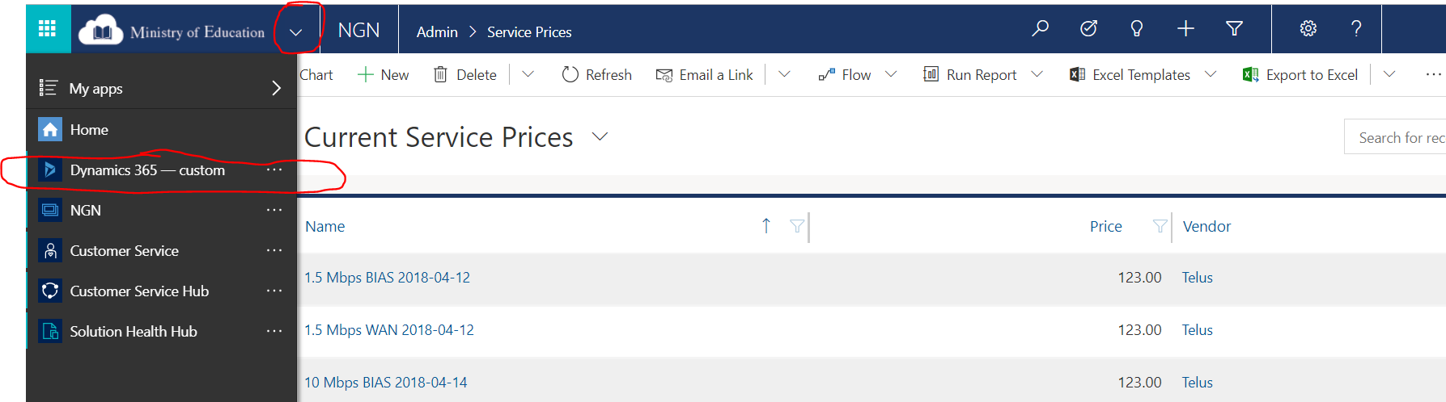

1. **Navigate to the Settings > Data Management section**
   1. Select Settings
   2. Select Data Management

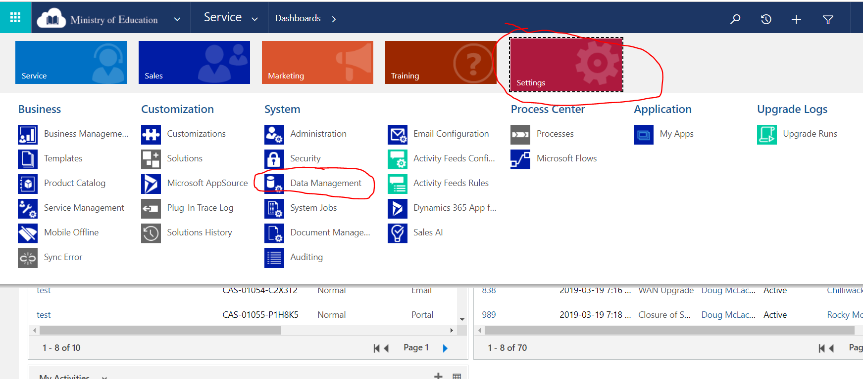

1. **Get a template for School Profile**
   1. Select “Templates for Data Import” 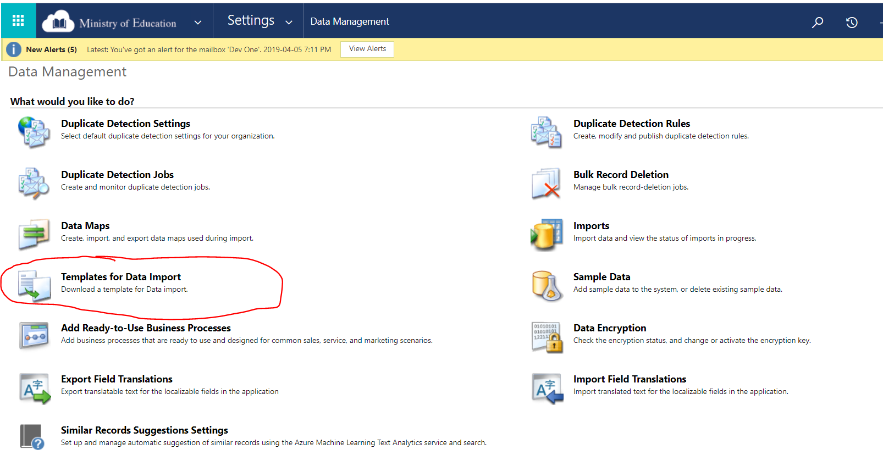
   2. Select “School Profile”

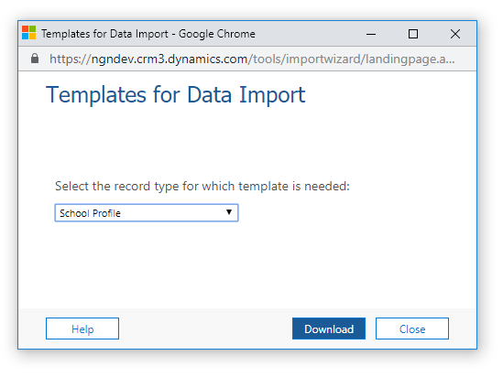

* 1. Click Download

1. **Fill in the excel document**
   1. Enable Editing if needed (yellow box on top of excel document)
   2. Copy the data from the 1701 data into the following columns:
      * School/Site – 1701 ID of the School
      * School Type – An option set e.g. Standard School
      * Enrolment Total – whole number
      * School Year – An option set e.g. 2018/19
      * Enrolment As of – Date (The format yyyy-mm-dd is recommended)
      * School Category – MOE School Type, Free text
      * Grade Range – Free Text
      * KH, KF, HS, SU, EU, Enrolment numbers
      * Grade 1-12 Enrolment numbers
   3. Leave the following columns blank:
      * Name
      * Created On
      * Created By
   4. Save the file
2. **Import the File**
   1. Select Imports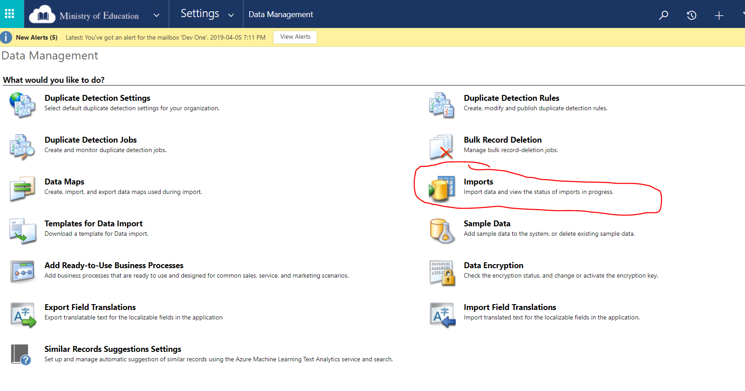
   2. Click Import Data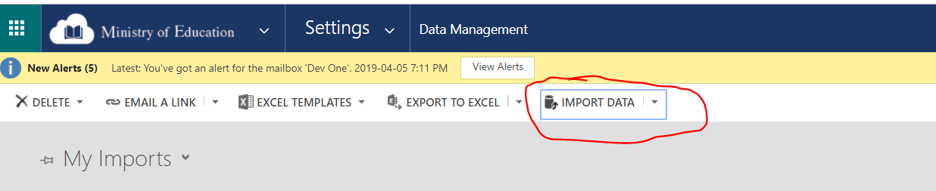
   3. Select your file and click Next

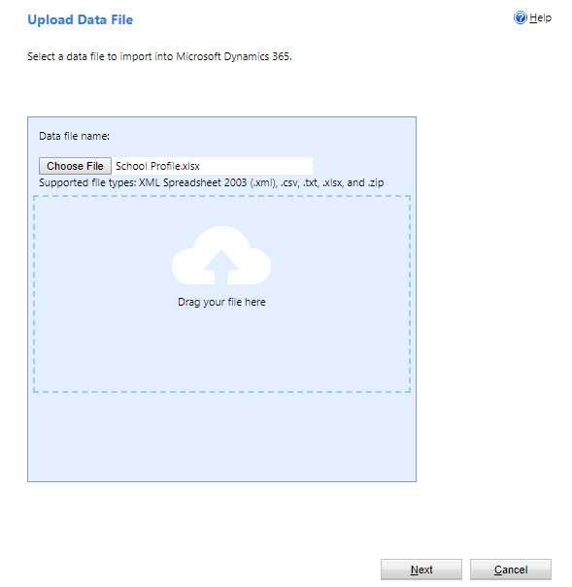

* 1. Click Submit
  2. Click Finish

1. **Check Import Success**
   1. 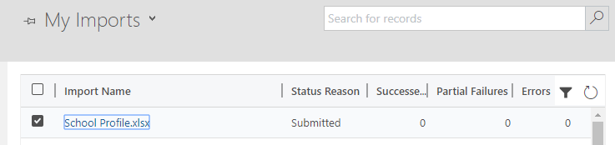Your import will be displayed under My Imports with a status of Submitted. It will take a few minutes to complete.
   2. Click the refresh button to see the updated status.
   3. If the Import failed, double click on the record to find out why

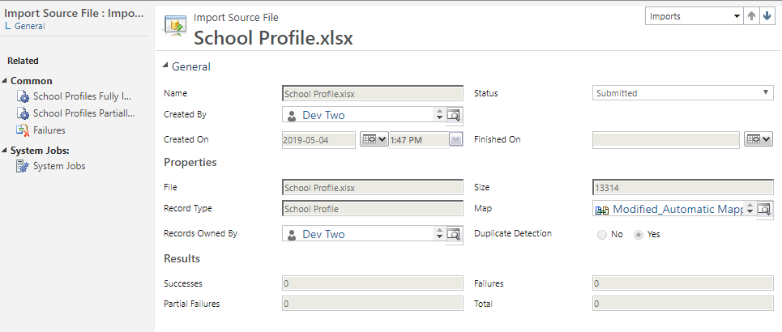

# Troubleshooting

1. Follow step #6 to check if the import worked.
2. Then double click on the import record and select either “Failed” or “Service Prices Partially Imported” on the left side of the screen.

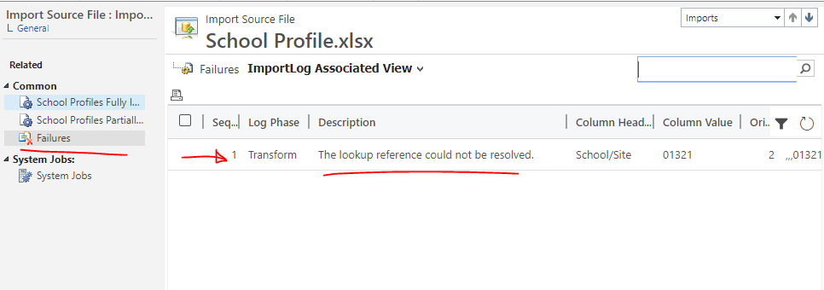

1. For Failed records
   1. Most likely you will see a message saying “The lookup reference couldn’t be resolved” and a Column Heading of School/Site. This means it couldn’t find a matching Site by the Site Number given.
   2. Double check your spelling and create a new import file with only these failed records.
2. For Partially Imported records
   1. Review what the error is
   2. Manually update the record